Level 22 -> Level 23

The goal of this level is to analyse a program that is running automatically at regular intervals from **cron**, the time-based job scheduler. We need to look in **/etc/cron.d/** for the configuration and see what command is being executed and search for the password.

This level is similar to the level 22.

* Use cd /etc/cron.d/ to enter into this directory.
* Use ls to check for files and folder in current directory.
* Use cat to read the content of cronjob_bandit23 file. This is the file which consists the task cron is doing.

@reboot bandit22 /usr/bin/cronjob_bandit23.sh &> /dev/null

* * * * * bandit22 /usr/bin/cronjob_bandit23.sh &> /dev/null

@reboot means - To run a job **every time the server is rebooted**

**\* * * * * means -** To run a cron job at **every minute**

**And cron is doing something in cronjob_bandit23.sh file in /usr/bin/ directory.**

* So, we will check in /usr/bin/ directory by entering into it using cd command.
* And using cat command read the content of cronjob_bandit23.sh file.

It consists #! /bin/bash script i.e. bash script as in level 22 but the script is different.

This script is reading content from the /etc/bandit_pass/bandit23 file and saving it to the file $myarget in /tmp folder.

* If we directly execute the script then the script will work with our current user name i.e. bandit22 and we will get the password of level 22 again. But we need the password of level 23.

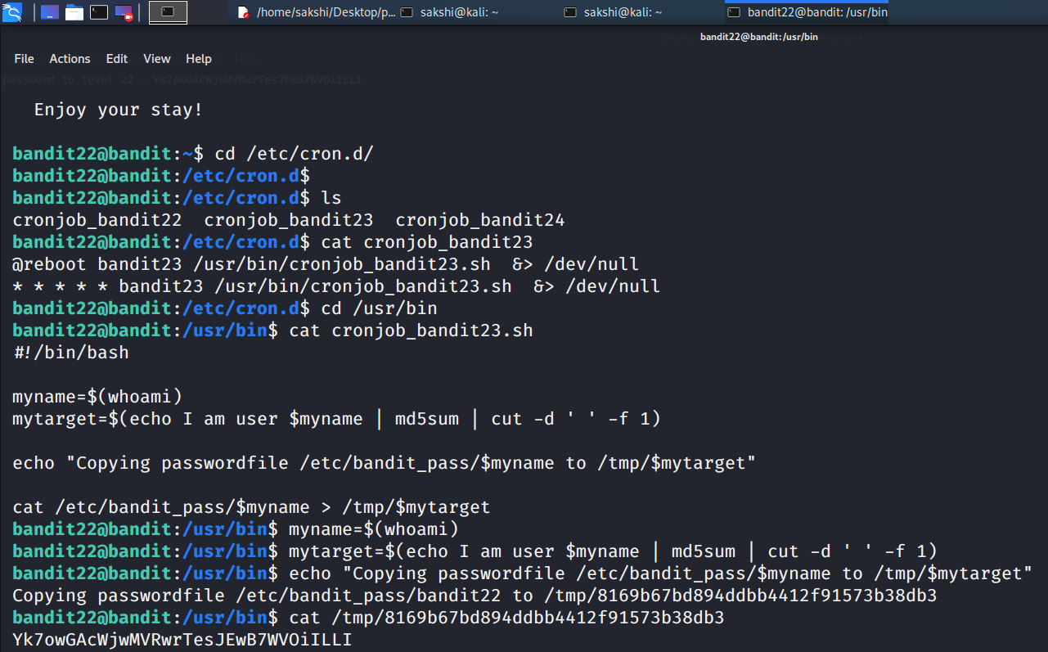

* So, we will try to enter user name manually in script myname=$(bandit23)
* But this will not work for us.
* Now we will try to run the script **echo I am user $myname | md5sum | cut -d ‘ ’ -f 1** by putting **bandit23 in place of $myname.**
* **Yeah!!!** This worked perfectly fine. We got the file name in which the script is saving the password for level 23.
* Use **cat /tmp/file_name** to read the password.

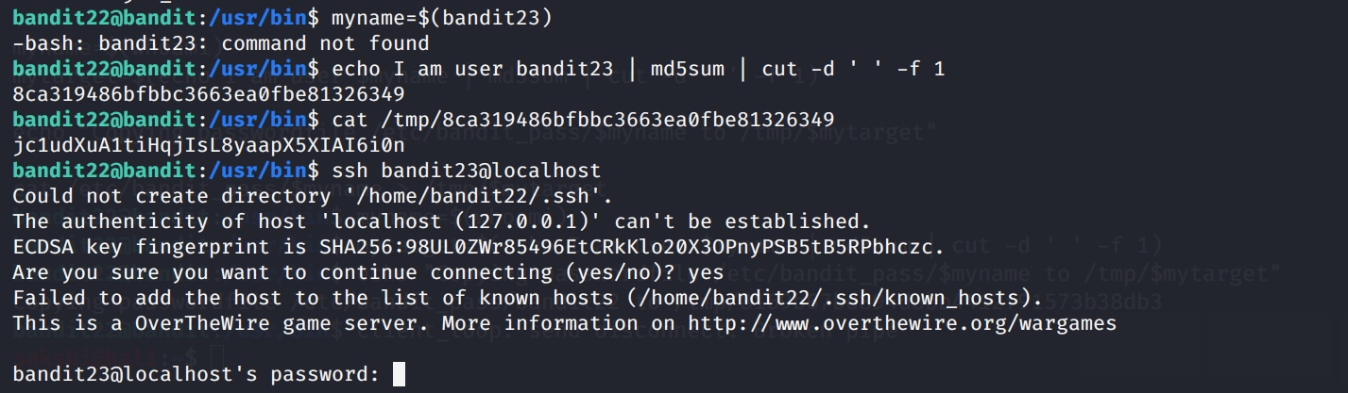

Use the command **ssh bandit23@localhost** to connect to the level 23.

Enter the password and hit enter.

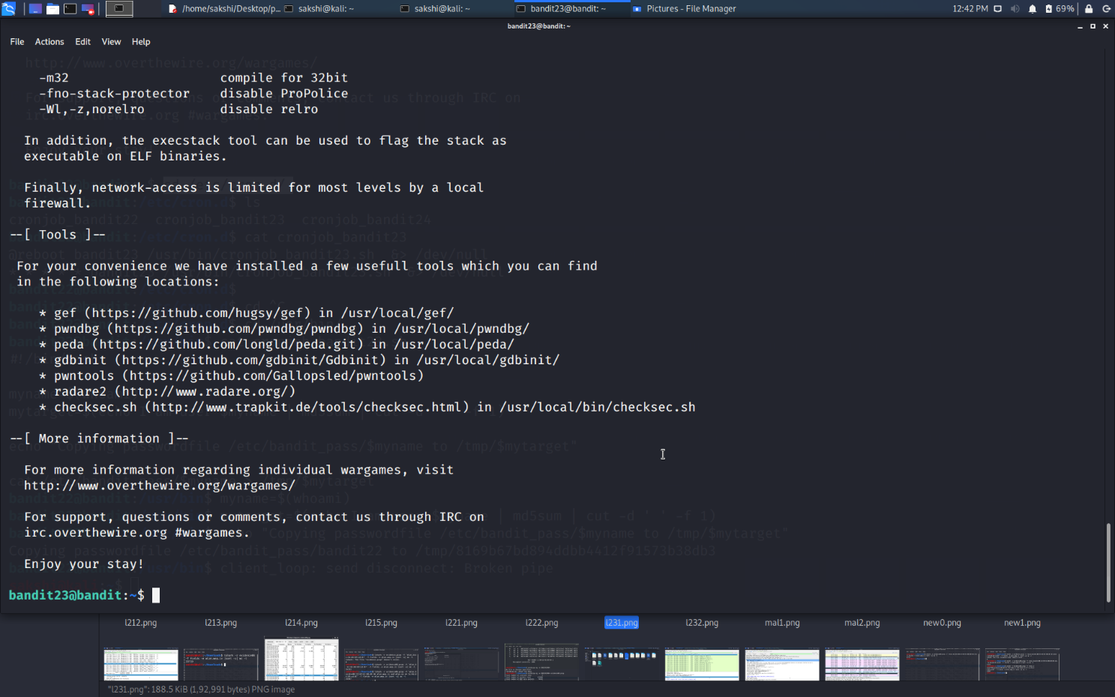

Successfully passed level 23.…